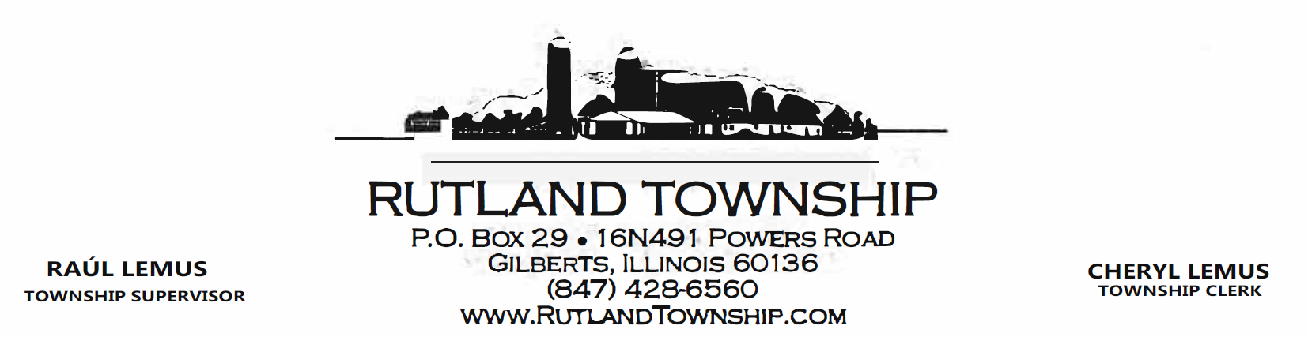TRUSTEES:
RICHARD ARTZ / JAN SIERS / SCOTT SWIDLER / STEVE KLEIN
HIGHWAY COMMISSIONER: JOHN ALESI
TOWNSHIP ASSESSOR: GARY FRITZ
BOARD OF TRUSTEES REGULAR BOARD MEETING AGENDA
April 14, 2026 5:45 P.M.
Pledge of Allegiance
Call to Order / Roll Call
Consent Agenda
- Review and possible approval of the following:
- April 14, 2026 Agenda
- March 10, 2026 Regular Board Meeting Minutes
Supervisor’s Announcements
Public Comment - Limited to 3 minutes per person (Persons wanting to speak must present signed request to Clerk prior to start of meeting)
Review/Discussion of the following Township Reports for March 2026:

Employee Earnings Summary | Expenses by Vendor Detail
Profit &Loss Budget vs. Actual | Check Detail

Review/Discussion of the following Road District Reports March 2026:
Employee Earnings Summary | Expenses by Vendor Detail
Profit &Loss Budget vs. Actual | Check Detail

Audit of February 2026 Bills:
Discussion / Possible Motion: Township bills for payment in the amount of $32,787.06
Discussion / Possible Motion: Road District bills for payment in the amount of $50,910.67
OLD BUSINESS: Discussion/Possible Motion: Possible Plans for the Commemoration of the 250th Anniversary of
the United States of America
NEW BUSINESS: Presentation of FYE 3/31/27 Budgets (Town, Road District, Assessor)
Presentation of Highway Commissioner’s Annual Report FYE 3/31/26
Executive Session (if needed)
Reports by Officials –Road Commissioner / Assessor / Trustees / Clerk
Adjournment of Township Board Meeting

